Testing:

Test (expected input test) Loading a level from a save file:

Input data of a filepath of C:\Users\Bailey\OneDrive\Documents\Test2

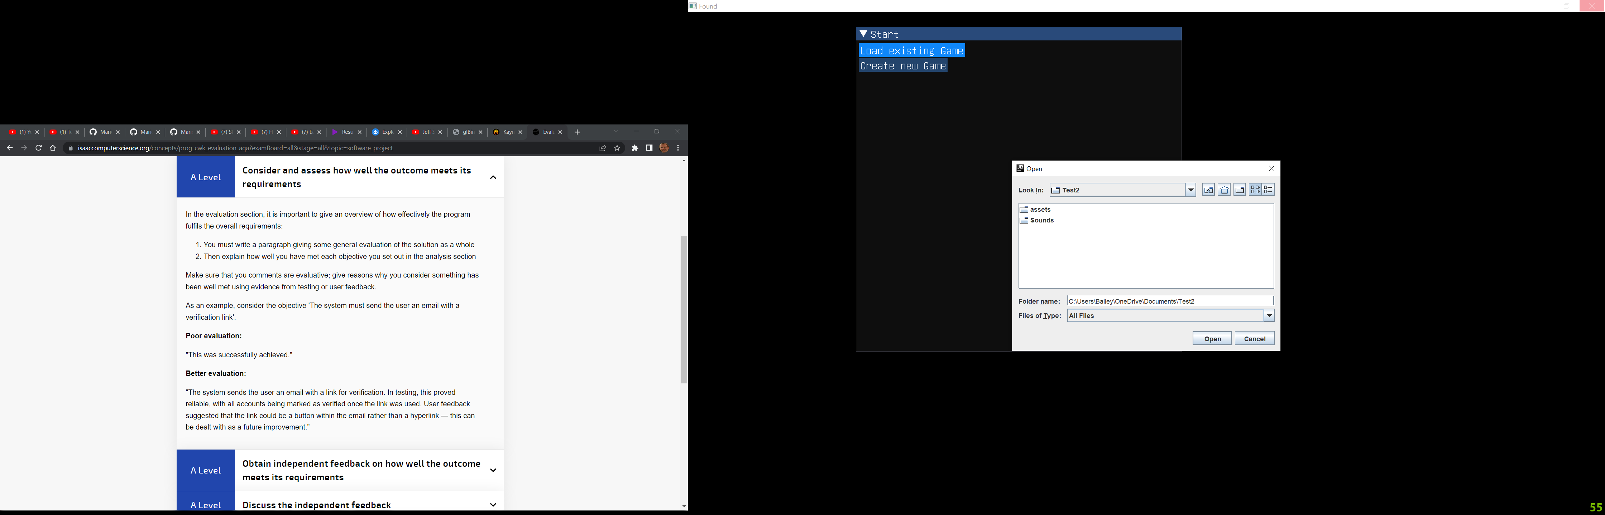

Expected outcome is to load the game with all its assets and objects loaded

Actual Outcome:

Fully loaded Game with imported assets loaded as well.

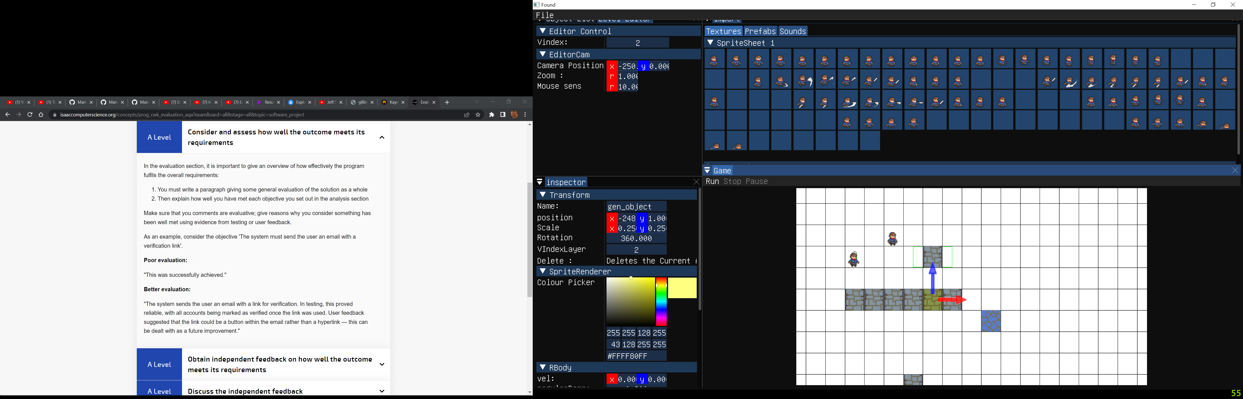

Test (erroneous test) Importing an incorrect file type as a sound file:

Input:

File of incorrect type.

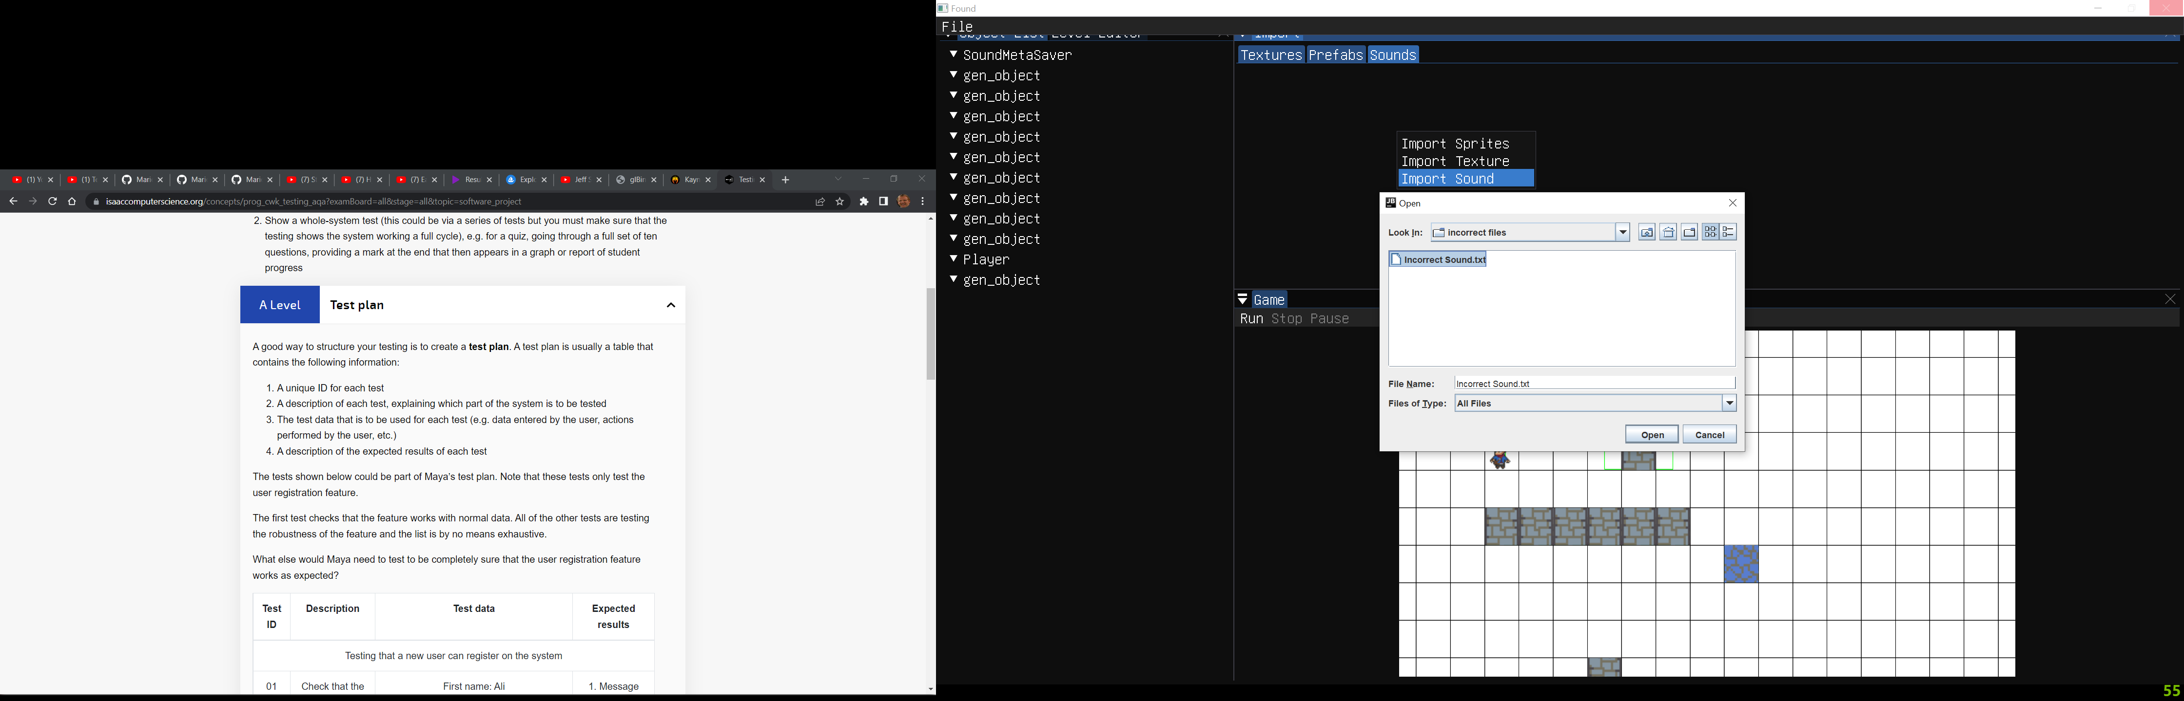

Expected outcome:

Error message telling the user the sound failed to load with the filepath of the incorrect file

Actual outcome:

Error message and filepath of the file.

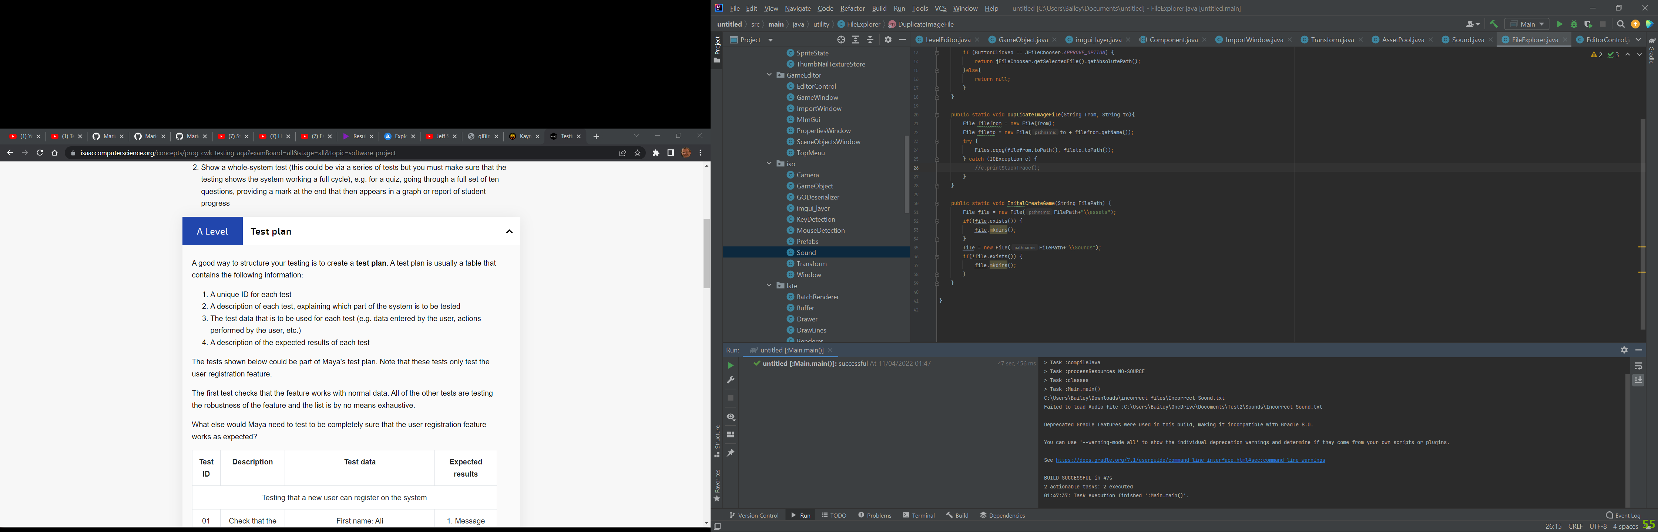

Test (boundary test) trying to import a file that already exists in the assets folder:

Input:

Importing a file that already exists in the games save file.



Expected outcome:

Stack Trace printed showing the line the code errored at and a reason and the code to continue to run

Actual outcome:

Prints stack trace of the error with a reason FileAlreadyExistsException with the file that already exists. Code continues to run.

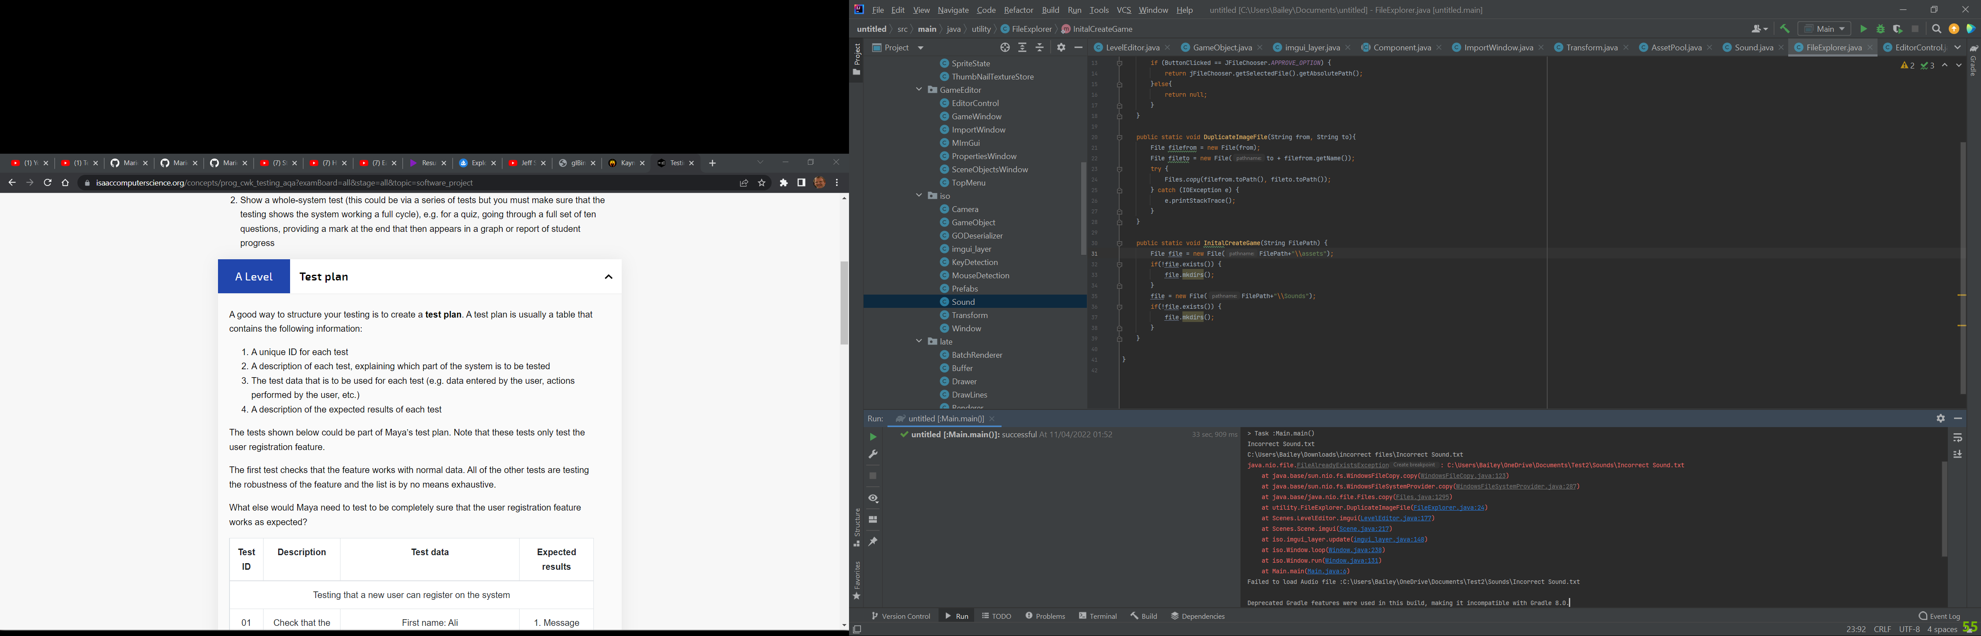

Test (erroneous test) trying to run the engine without a shader:

Input:

Shader that doesn’t exist

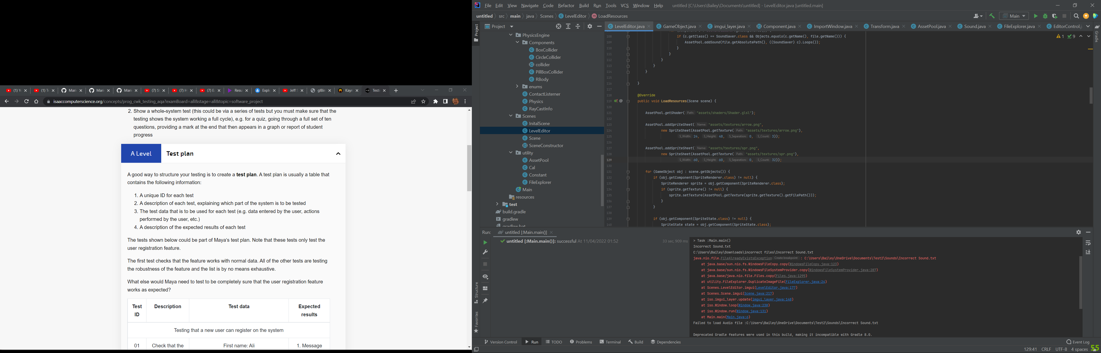

Expected outcome:

Code halts. Prints an error Saying that the shader failed to be opened and another error saying that the shader file does not exist.

Actual outcome:

Code halts printing 2 error

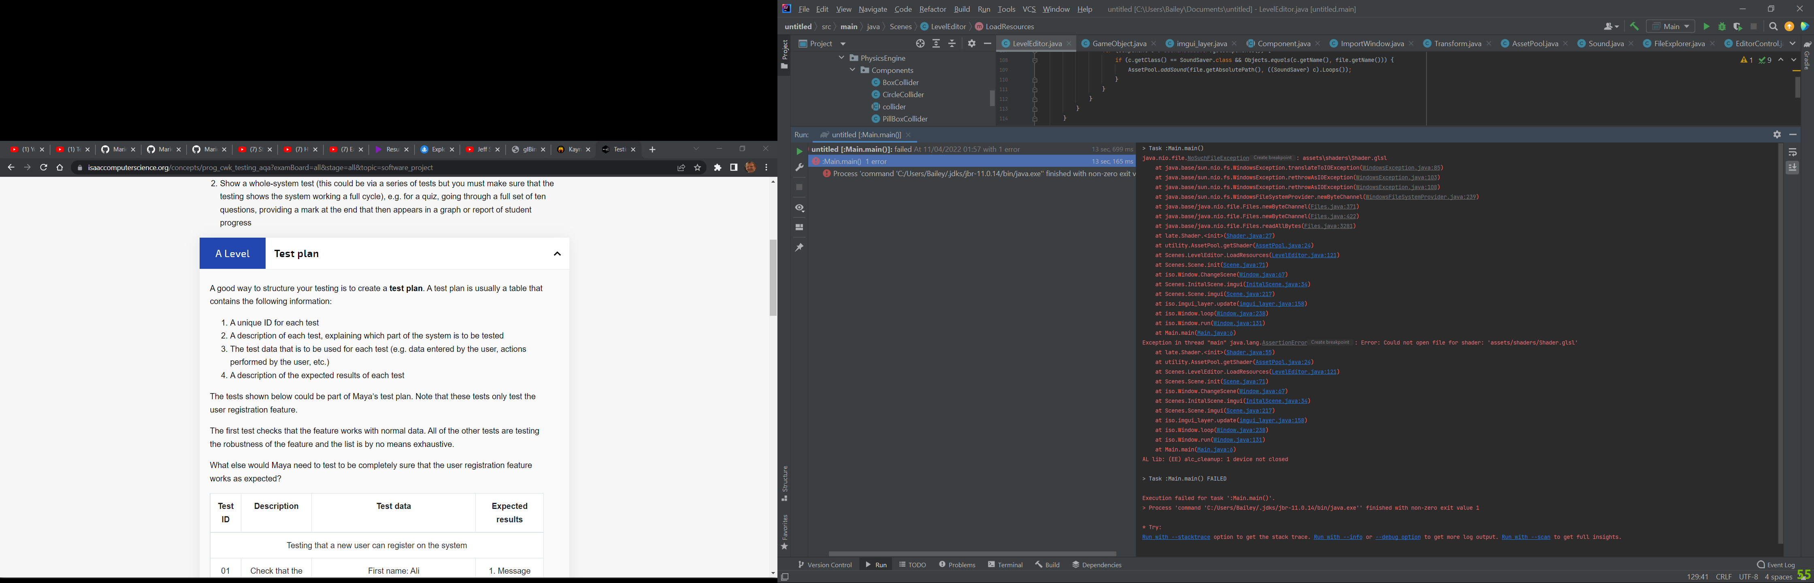

Test (expected data) importing a texture and giving it the desired components. Trying to add these to the viewport at checking their components.

Input:

importing a texture entering 32,32 in width and height, 104 in the texture count and zero in the texture separation. Then selecting the rigid body and box collider components.

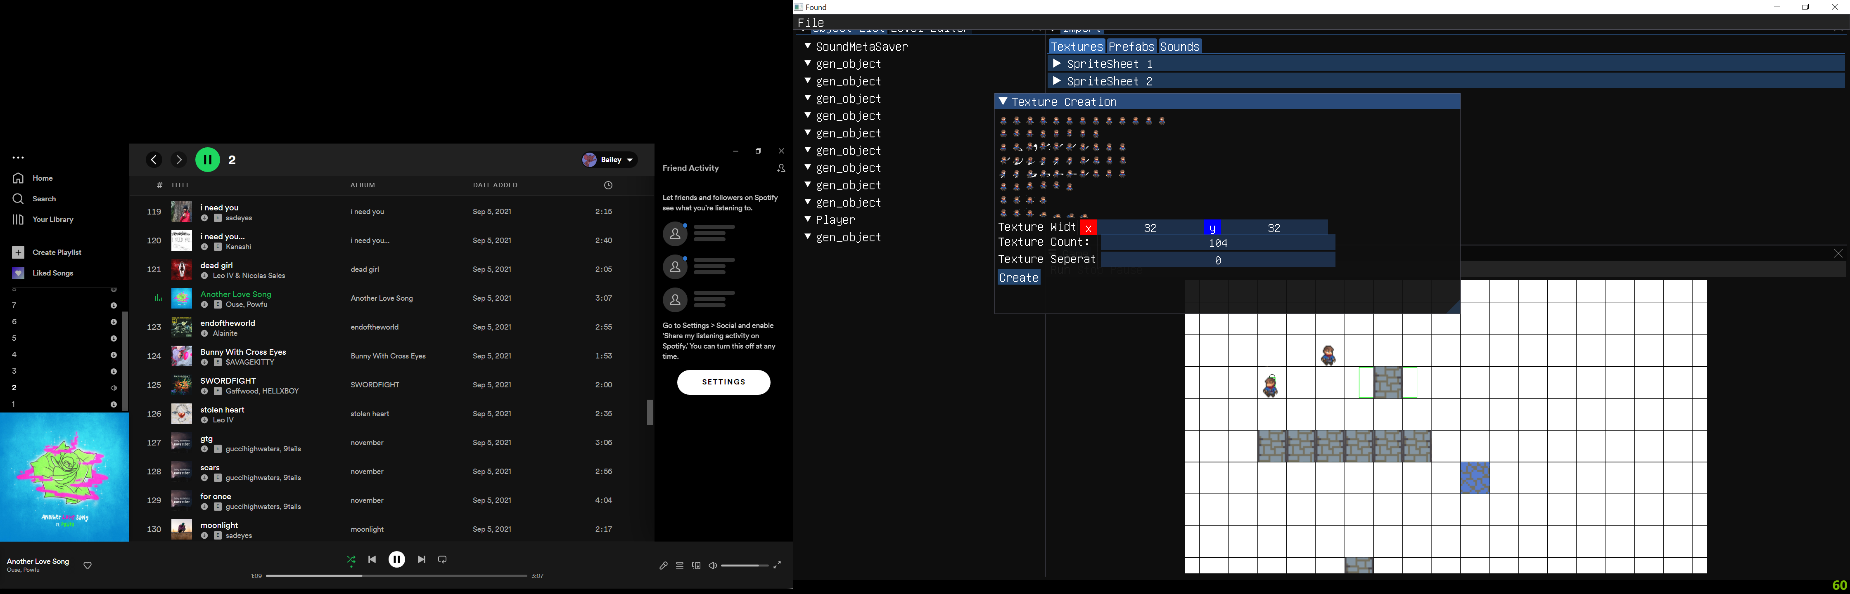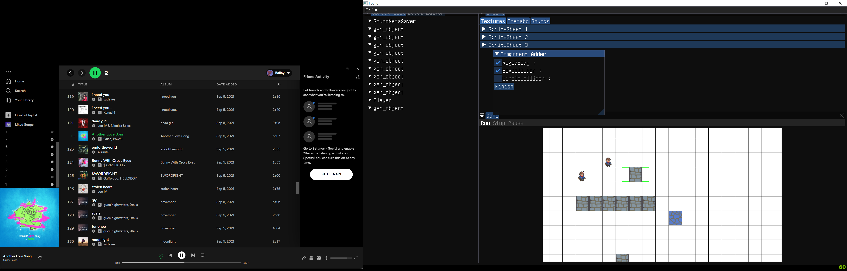

Expected outcome:

Textures are created successfully and when added to the viewport have a box collider and a rigid body component.

Actual outcome:

Sprite sheet created and displayed as image buttons. When imported into the viewport a gameobject is created with a box collider and a rigid body component as selected in the input.

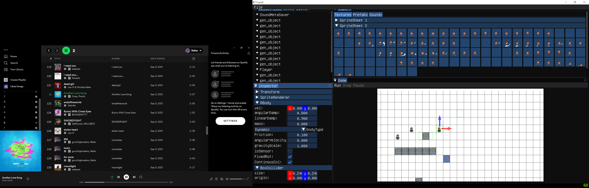

Test (erroneous data): trying to load a game from an empty folder

Input:

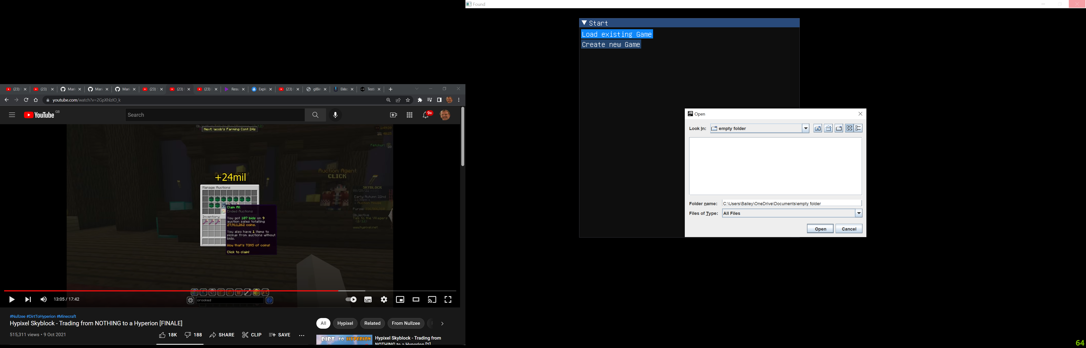

Expected outcome:

Errors telling the user that the game save files are missing and creating a blank game save.

Actual outcome: Creates a blank game. Outputs errors saying the game files don’t exist

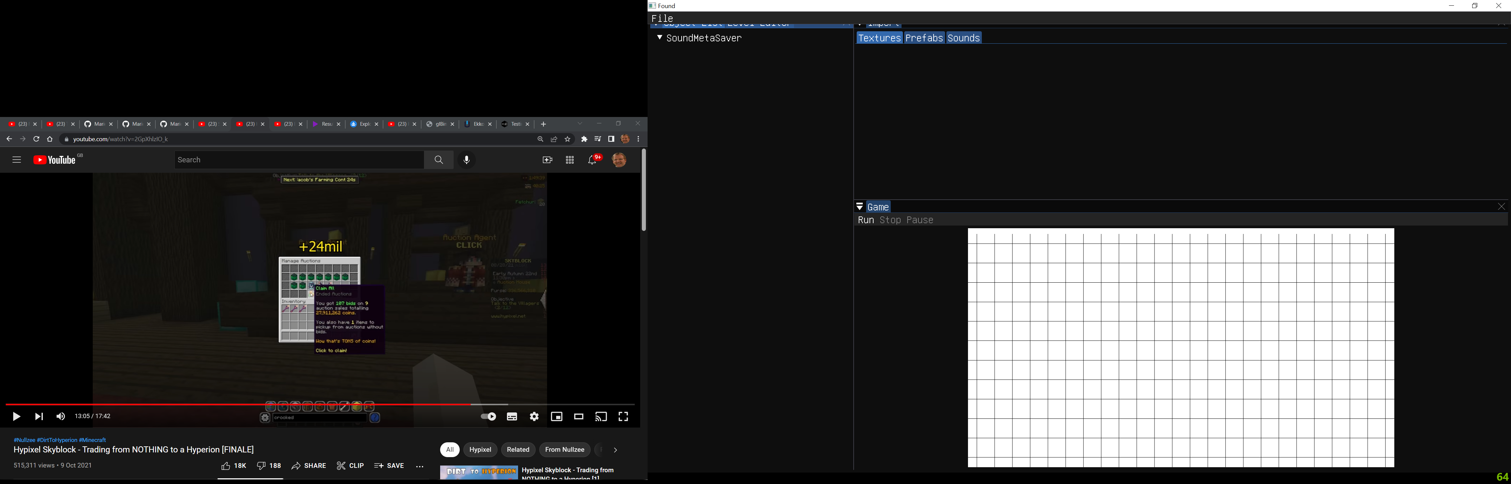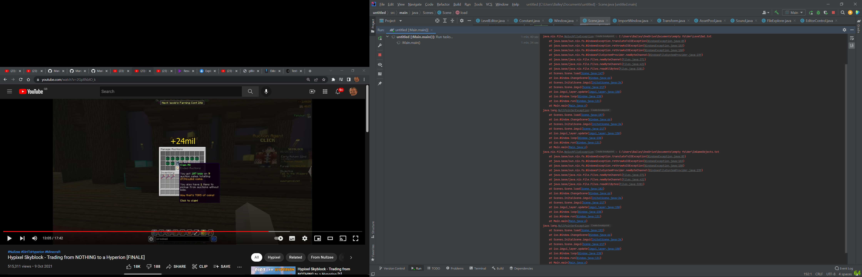

Test (boundary data) when creating a texture, go to the limit of what is allowed for the width, height, and count variables

Input: try to input 0,0 in width and height and 0 in texture count.

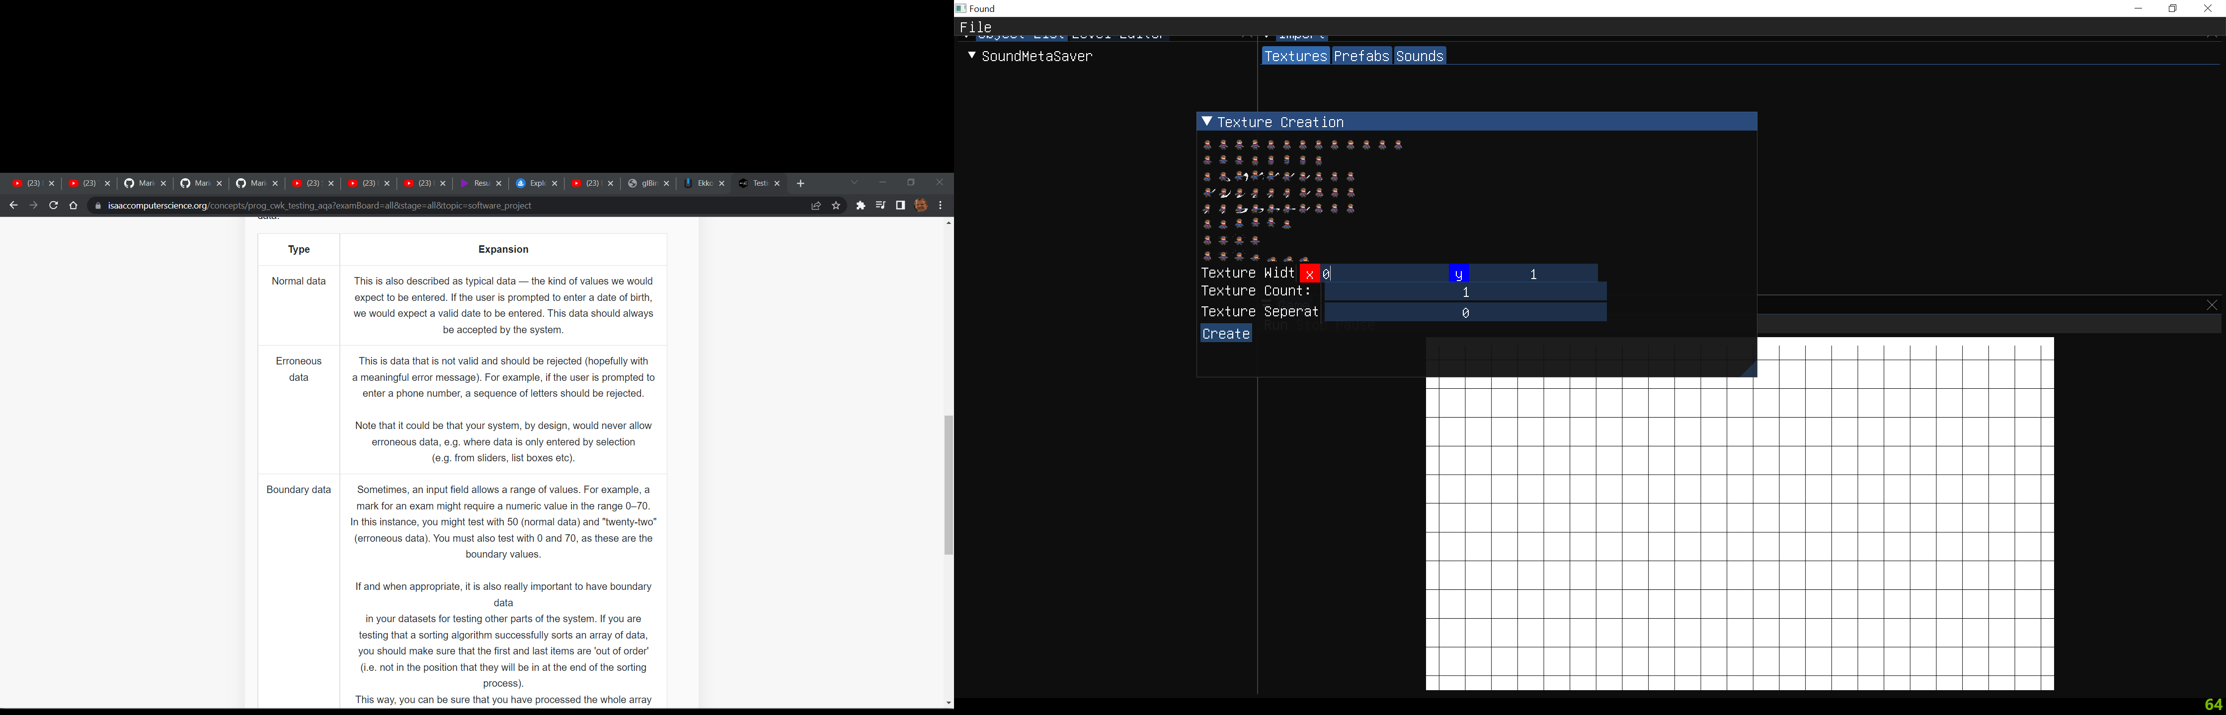

Expected outcome:

These inputs will not be allowed, and they will be set to their default value of 1 if a value smaller than 1 is input.

Actual outcome:

The inputs are set to 1 when 0 is input into these 3 values

